## Mila Myrick (2007-September 18th 2020)

Index

### General info

Mila was born

### Previous life

Mila had a series of abusive and neglectful owners before we got her from the humane society. One aspect that helped us pick her out was that she was jumping up and making a praying motion at the gates, telling us that she didn’t want to be at the humane society anymore. So we took her home, as a test trial. Sean became attached with her very quickly, and we ended up keeping her.

### **Good** life

We gave Mila a good ending to her life, and made a good chunk of her life better. She was a very energetic dog at the time, but she was still traumatized.  
Over the years, Mila developed dementia. She constantly started barking at everything. She even bit Milly on the ears and got her ears infected. She constantly got into fights, and over time, became blind as well. She would later get sprayed by a spray bottle in her final months when she started barking. She would always go outside with the rest of the family, but then either go to the front door or the garage door barking to get back in immediately. When she started going blind, she was tripping over everything, barking at the wall to get in (instead of the door) and she became very aggressive. She did not go with us on our 2020 Cannon Beach vacation due to this and other problems. Meme expected Mila to die by the time we got back. When we got back, she was still doing fine, but later did worse.

### Memories

### Death

On September 16th 2020, Mila was refusing to eat or drink. She has been deteriorating for a long time. She developed Dementia in the last 2 years of her life, and on September 16th 2020, she did not do well. Sean was not fully aware of this at the time. She slept in my area, something she never did before.

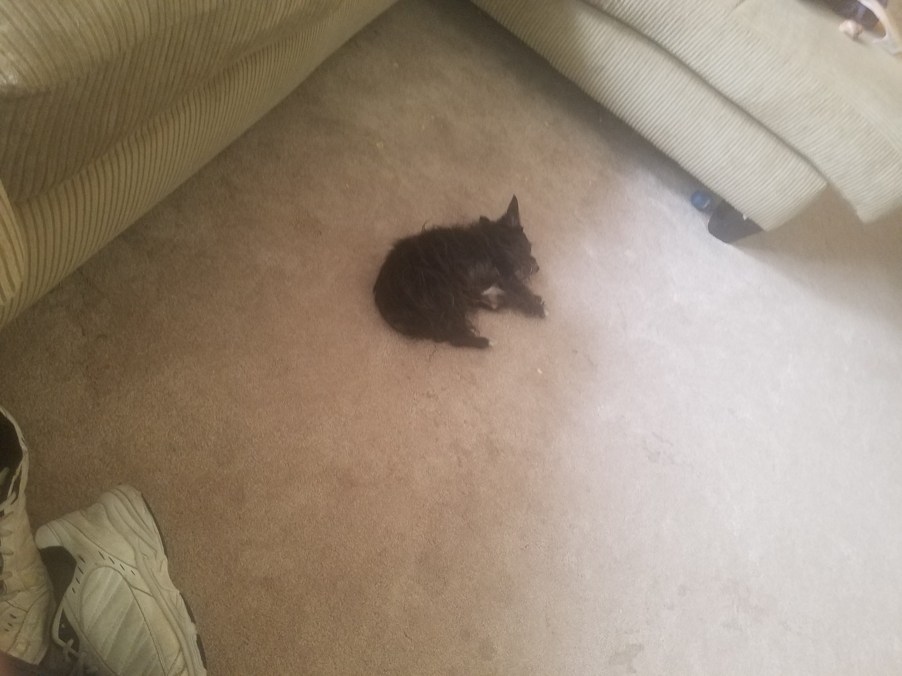Angle 2:

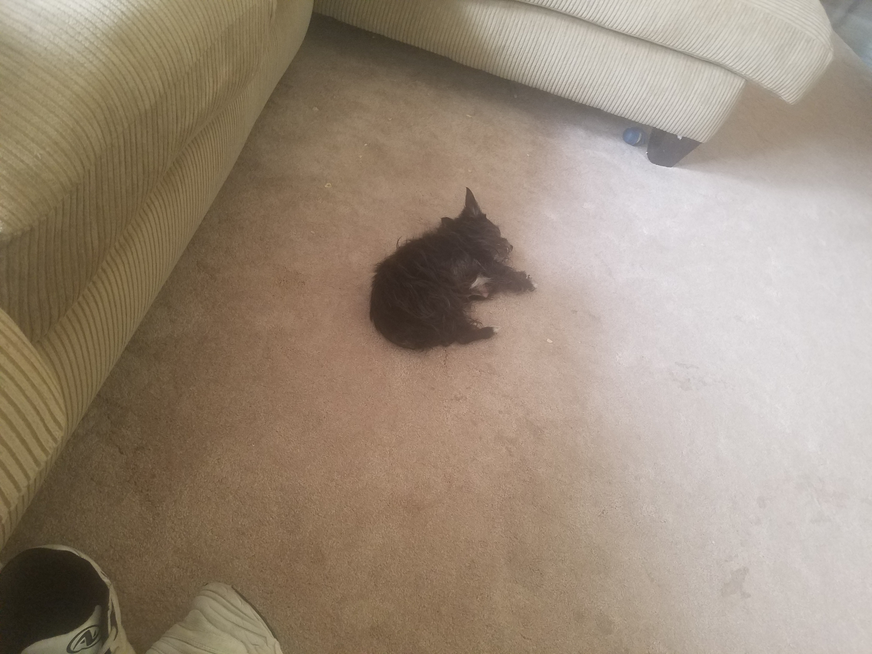

On September 17th 2020, Mila started to get worse. She wandered around a bit outside with meme, she was almost completely blind, and was lost.

Video here

She was taken in the house. She laid down, and Sean began to grieve her. She was not going to make it much longer. I tried to make an impression on her, so that she would remember me when she died. I left her alone after a while, as that is what she wanted. She was in a familiar area in her bed.

Later that night, as I was finishing up my work, at 10:40 pm, I began to hear a screaming sound. I grabbed my phone and went and used the flashlight. It was Mila, she was yelping in pain. I went and got meme, and we pet her a bit. She got better, but meme said that when she makes it through the night, she will have to be euthanized tomorrow. She was experiencing organ failure tonight. She has had problems with her heart for years, and had to take medication for it. None of us want to see her suffer, she doesn’t deserve to suffer. She was better through the night, and she continued to sleep.

On September 18th 2020, Mila was alive. She made it through the night, but she was suffering too much to be alive. We called the vet clinic to get her euthanized. The appointment was at 10:00 am. In the time leading up to this, she was mostly asleep, but at one point she began to have heart problems and she started yelping repeatedly. We pet her a bit, then let her relax in the quiet of her area, as that is what she wanted. We later took her out to the car in her bed. She was reeking due to going to the bathroom on herself. We took her to the vet clinic, and got 2 final pictures of her:

1

2

Mila began to get put down. She was already asleep. Meme kept whispering in her ear “good girl Mila” and then she received the final dose, and died quickly. At 10:14 am, on Friday, September 18th 2020, Mila died. There was a lot of grievance for the rest of the day. We have lost a member of our family. The moments with Mila have ended. I will never be able to see her again.

# R.I.P

## Mila Myrick

## 2007-September 18th 2020